The Henry and William Williams Memorial Museum Trust
P O Box 12426
Thorndon
Wellington 6144
New Zealand

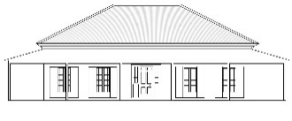

NEWSLETTER #7 AUGUST 2016

Dear Family and Friends,

Our museum web-site (www.williamsmuseum.org) is already attracting attention, with regular visits to the site each week. Just lately students from the Bay of Islands College have been contacting us through the site for help with a project on the relationship between Henry Williams and Hone Heke. More work is being done on the site, so stand by for updates.

On the website you will see the range of Williams’ memorabilia in our museum collection. This has been added to this year with a miniature portrait of Thomas Williams (father of Henry and William) generously donated by English relatives. You can see an image of this miniature on the website tab - go to English family history.

The Trust has been busy this last year with the house and garden both requiring attention. As always with an old house -163 years now- things wear out and need replacing. We want it to be waterproofed, and roof replacement is now a high priority. Hard on the heels of that is the completion of window and door joinery restoration, another source of leaks. The roof is a key project for 2016 and a grant towards this has been made through the generosity of the JN Williams Memorial and Turanga Trusts. We have made an application to the Lotteries Environment and Heritage Fund for the balance but competition is intense for such funding. We will hear the result in November.
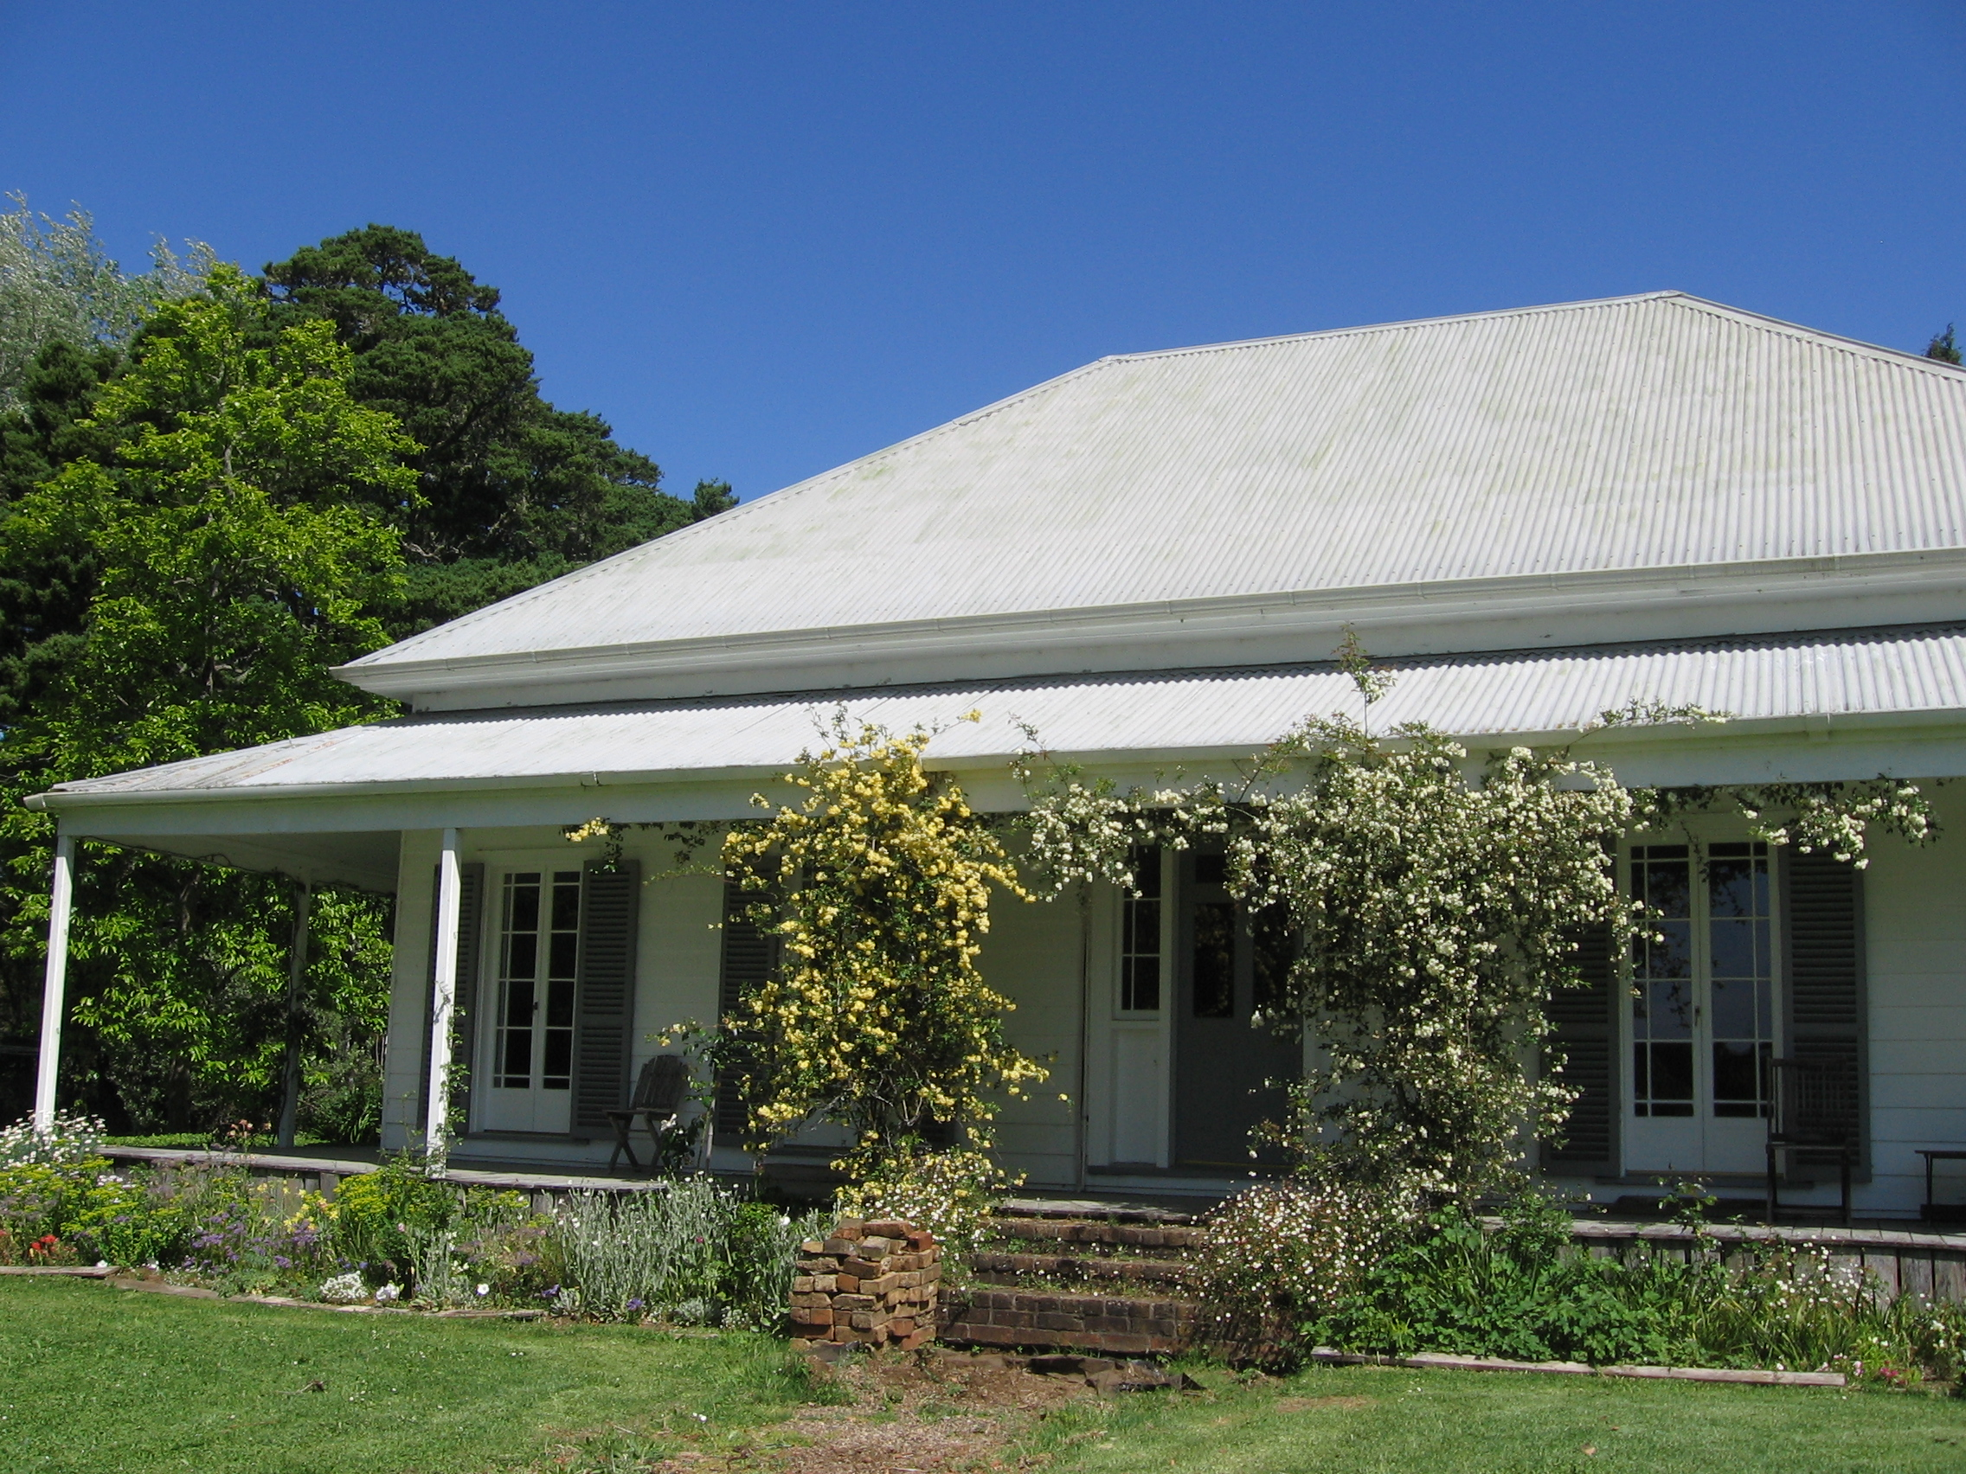
We aim to have the house, the Retreat, fully restored by 2023 – the year of the bicentennial of the first arrival of a Williams family. The year is jointly celebratory of Henry, William, Marianne and Jane whose lives and exploits are an important part of 19th century colonial history. What better tribute than to have the house in top condition for this important occasion.

The above photograph, taken in spring 2015, shows the main door framed by climbing roses (and the brick steps under repair). The house is set in sweeping gardens which improve every year as a result of donations of trees and shrubs and the hard work of Geoff and Pam Pickles who rent the property. Significant sums have been spent on weed control – wild ginger being the chief culprit. The pavilion housing Henry Williams’ gravestone is an important addition to the garden. Please have a look at it on the web-site.

Last Labour Weekend we held a very successful Open Day, which we are repeating this year on Sunday, November 6 from 10.00 am – 4.00 pm. Everyone is welcome to come and see the exterior of the house in its garden setting and we particularly welcome family members who have never seen the property.

Finally, we are asking for donations to help us achieve our restoration goals. We are very limited in the extent to which we can get funding from Government and community sources because of being a private charitable trust. Family and friends are therefore critical. Our Trust has developed a detailed seven-year plan to complete restoration work and provide display space and storage for collection items. The total cost is estimated to be in the order of $200,000 - an achievable goal if everybody pitches in.

Your contribution will help preserve a significant heritage property and make possible a museum project that memorialises the lives of the missionary brothers and their wives who played such an important role in pre-Treaty New Zealand. Please can you help us? Remember donations are tax deductible and we will issue an appropriate receipt. Cheques should be sent to our post box but for internet banking please direct credit the H & W Williams Memorial Museum Trust, a/c number 03 0518 0168756 00 – note in the transfer your name and put ‘donation’ in the reference panel. Please support your valuable heritage. Many thanks!

And again looking forward to the Bicentenary in 2023, for which planning is already underway, please remember to send us your emails (and changes of email) to keep our list up to date. We can be contacted on williamsdescendants@gmail.com or williamsmuseum@gmail.com

With best wishes

John Andrews (Chairman) Tina Angelova, Camilla Hope-Simcock, Kirsty McGill, Eila Searles, Charlotte, Dan, Gerry and Priscilla Williams.

Trustees for the Henry and William Williams Memorial Museum Trust

